**Past Paper 2015**

**Q#1: Define Term Sociology?**

**What is Sociology?**

Sociology is the study of human social relationships and institutions. Sociology’s subject matter is diverse, ranging from crime to religion, from the family to the state, from the divisions of race and social class to the shared beliefs of a common culture, and from social stability to radical change in whole societies.

Unifying the study of these diverse subjects of study is sociology’s purpose of understanding how human action and consciousness both shape and are shaped by surrounding cultural and social structures.

Sociology is an exciting and illuminating field of study that analyzes and explains important matters in our personal lives, our communities, and the world. At the personal level, sociology investigates the social causes and consequences of such things as romantic love, racial and gender identity, family conflict, deviant behavior, aging, and religious faith.

At the societal level, sociology examines and explains matters like crime and law, poverty and wealth, prejudice and discrimination, schools and education, business firms, urban community, and social movements. At the global level, sociology studies such phenomena as population growth and migration, war and peace, and economic development.

Sociologists emphasize the careful gathering and analysis of evidence about social life to develop and enrich our understanding of key social processes. The research methods sociologists use are varied. Sociologists observe the everyday life of groups, conduct large-scale surveys, interpret historical documents, analyze census data, study video-taped interactions, interview participants of groups, and conduct laboratory experiments.

**Q#2: Major Perspectives in Sociology?**

Sociologists analyze social phenomena at different levels and from different perspectives.

Sociologists today employ three primary theoretical perspectives:

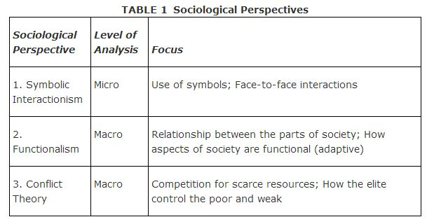

**1-**The **symbolic interactionist perspective**, also known as **symbolic interactionism**, directs sociologists to consider the symbols and details of everyday life, what these symbols mean, and how people interact with each other.

**2-** According to the **functionalist perspective**, also called **functionalism**, each aspect of society is interdependent and contributes to society's functioning as a whole. The government, or state, provides education for the children of the family, which in turn pays taxes on which the state depends to keep itself running.

3- The conflict perspective, which originated primarily out of Karl Marx's writings on class struggles, presents society in a different light than do the functionalist and symbolic interactionist perspectives. While these latter perspectives focus on the positive aspects of society that contribute to its stability, the **conflict perspective**focuses on the negative, conflicted, and ever‐changing nature of society.

Q#3: Define Term Culture ?

**Culture** is everything made, learned, or shared by the members of a society, including values, beliefs, behaviors, and material objects.

Culture is learned, and it varies tremendously from society to society. We begin learning our culture from the moment we’re born, as the people who raise us encourage certain behaviors and teach their version of right and wrong. Although cultures vary dramatically, they all consist of two parts: **material culture** and **nonmaterial culture**.

#### Material Culture

**Material culture** consists of the concrete, visible parts of a culture, such as food, clothing, cars, weapons, and buildings. Aspects of material culture differ from society to society. Here are a few features of modern material culture in the United States:

* Soy lattes
* CD burners
* Running shoes
* iPods
* Lifestyle magazines
* Organic vegetables
* Sport utility vehicles

***Example:****One common form of material culture is jewelry that indicates a person’s status as married. In American culture, people wear a metal band on the ring finger of the left hand to show that they are married. In smaller, nonindustrialized societies, everyone knows everyone else, so no such sign is needed. In certain parts of India, women wear a necklace to indicate that they are married. In Northern Europe, married people wear wedding bands on the right hand.*

#### Nonmaterial Culture

**Nonmaterial culture** consists of the intangible aspects of a culture, such as values and beliefs. Nonmaterial culture consists of concepts and ideas that shape who we are and make us different from members of other societies.

* A **value** is a culturally approved concept about what is right or wrong, desirable or undesirable*.* Values are a culture’s principles about how things should be and differ greatly from society to society.

***Example:****In the United States today, many women value thinness as a standard of beauty. In Ghana, however, most people would consider American fashion models sickly and undesirable. In that culture and others, robustness is valued over skinniness as a marker of beauty.*

***Short Question***

***Q#1: Difference in Sociology and Community?***

**(2)** Society has no definite locality or boundary because it refers to a system of social relationships. Hence it is universal or pervasive. On the other hand a community always associated with a definite locality.

**(3)** Community sentiment is another important factor from which society and community can be distinguished from each other community sentiment is an essential characteristic of community. Without which a community can’t be constituted. But a society may or may not have community sentiment

ADVERTISEMENTS:

***Q#2: Critical Thinking in Learning Process and Problem Solving?***

Critical thinking is the process of rationally analyzing and attempting to solve a problem accurately and efficiently without relying on assumptions or guesses. For students, critical thinking is an important part of the research and learning processes. Business leaders rely on critical thinking to help them solve day-to-day problems, along with major organizational issues, at minimal cost and as quickly as possible.

## **Assess and Restate the Problem**

One of the central strategies to critical thinking and problem solving is developing as complete an understanding as possible of the problem.

**Q#3: Order and Stability In Society?**

Examples are the ancient, the feudal, and the capitalist social **order**. In the second sense, social **order** is contrasted to social chaos or disorder and refers to a **stable**state of **society** in which the existing social **order** is accepted and maintained by its members.

Social order is a fundamental concept in sociology that refers to the way that the various components of society—[social structures](https://www.thoughtco.com/social-structure-defined-3026594) and institutions, social relations, social interaction and behavior, and cultural aspects like [norms](https://www.thoughtco.com/why-a-norm-matter-3026644), beliefs, and values—work together to maintain the status quo.

Q#4: